National Federation of the Blind of Idaho
Dana Ard, President
1320 E. Washington
Boise, ID 83712
(208) 345-3906
pres.nfbidaho@gmail.com
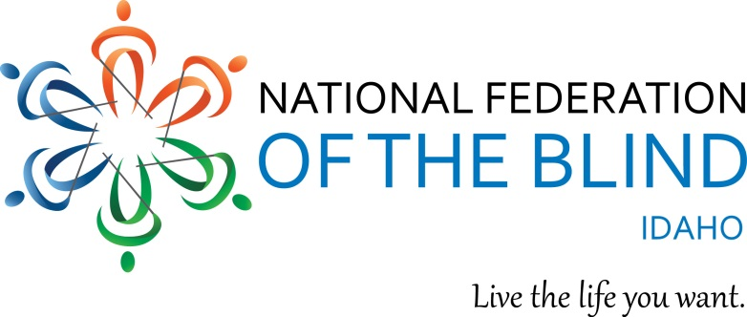
2026 NFBI State Convention Agenda

April 23-25, 2026 in Boise ID
Best Western Vista Inn, 2645 Airport Way, 208 336-8100

Convention theme: “Who Are We, NFB”

Our National Representative will be Tom Page, President of NFB of Kansas and a National Board Member.

Hospitality will be in the Owyhee Room It will be open Friday 12 – 2:00pm , 5—700pm; Saturday 12:00—2:00pm, 6:00 – 7:00.

Convention Registration will be open: Thursday, 6:30 – 7:30 pm, Friday, 8:00 – 8:45 am, Saturday, 8:00 – 8:45 am.

Thursday, April 23

7:30 Rookie Round-up Come join us to learn more about our organization, and get to know one another
Quincie Mattick, Cindy Grover, Shane Ostermeier

8:00 Bingo Night: Come and have some fun, win prizes, and spend time together Cindy Grover, Tj Squires, Vickie Bateman

9:00 Resolutions Committee Meeting Summit Room

Friday, April 24, 2026
Sawtooth Bitterroot Room

9:00 America’s Music Through the Centuries
9:15 Invocation & Announcements
9:20 Who are We, NFB: Ramona Walhof , Vickie Bateman, Shane Ostermeier,
9:40 Idaho’s Able Project: Jamie Davis
10:05 Serving blind Idahoans Through ICBVI Programs: Beth Cunningham
10-25 Fit Break, Marcie Chapman
10:30 IESDB Update: Jeanne Marie Kopeckey
11:00 Idaho Assistive Technology Project: Jeff Mason and Krista Kramer
11:25 Changes to talking book services in Idaho: LeeAnn Gelskey
11:50 Reports and Resolutions

12:00 Lunch on your own. hospitality room is open

12:30 Vendor and Member Exhibits

2:30 What makes BELL and Beyond so much fun? Dominic Budell, Bell and Beyond participant
2:45 Grief and Loss, Dallas Payton, Payton Counseling Services
3:45 A tribute to Sandy Streeter
4:15 Membership and Leadership. Discussion of the relationship of affiliates to our national organization. How can affiliates support our national organization? What does our national organization do for us? Tom Page and all attendees
5:00 Break

6:00 State Affiliate Board Meeting and Dinner
7:30 Open Mic. Share your stories, music, comedy. We want to hear it
9:30 Open Jam Session

Saturday, April 25
Sawtooth Bitterroot Room

9:00 Invocation and Announcements
9:10 National Report, Tom Page, National Board Member
9:50 Explanation of our fundraiser baskets
10:00 State Report, Dana Ard, NFBI President
10:25 Fit Break, Marcie Chapman
10:30 Planning next year’s goals for our state affiliate, all member discussion
11:00 Annual Business Meeting
12:00 Lunch on your own, Hospitality room is open
12:00 Student and Young adult luncheon: Prior registration required

2:00 Meet Kriszta Gruebele, Teacher of Tomorrow, Teacher of blind children
2:20 Sending our Message to the world, new ways our NFB is reaching out: TJ Squires
2:55 Auction Item
3:00 Advocacy in Action: Shane Ostermeier, Nicole Hill, Joe and Cindy Grover
3:25 Fit Break
3:30 Member engagement, fundraising, Q & A with Tom Page
4:00 Published author tells his stories: Kevin Pirnie
4:20 Auction Item
4:30 Getting to know our scholarship winners
5:00 Break

NFB Pledge

I pledge to participate actively in the efforts of the National Federation of the Blind to achieve equality, opportunity, and security for the blind; to support the policies and programs of the Federation and to abide by its Constitution.

6:30 Banquet

Invocation: Bose Pirnie
Mistress of Ceremonies: Susan Bradley, NFBI Secretary, President Treasure Valley Chapter

Banquet Address: Tom Page, National Representative

Presentation of Scholarships: Joe Grover, Scholarship Committee Chair

Funding our movement through the Preauthorized Contribution Plan: Ramona Walhof, PAC Chair

Our Final Door Prize will be $200.00, given by Treasure Valley Chapter

Convention Adjourned

Convention Committees

Convention Planning Committee: Cindy Grover, Tj Squires, Nicole Hill, Quincie Mattick, Shane Ostermeier

Scholarship Committee: Joe Grover, Chair, Shane Ostermeier, Mike Gibson, Leslie Squires Vickie Bateman, Quincie Mattick

Nominating Committee: Leslie Squires, Chair, Fawn Owens, Lynn Kneip

Registration Committee: Don Winiecki, Susan Bradley, Angela Bradley

Door Prizes: Krystal White, Chair, Andy Johnson, Olivia Johnson

Raffle Baskets: Liz Kneip,

Resolutions Committee: Tj Squires, Chair, Nicole Hill, Krystal White, Vickie Bateman,

Hospitality Room: Sue Brooks

