2026 NFBI State Convention Registration
April 23-25, 2026 in Boise ID
Best Western Vista Inn, 2645 Airport Way, 208 336-8100

Convention theme: “Who Are We, NFB”

Get ready to join our Federation family at the 2026 state convention,
Back In Boise, ID, at the Best Western Vista Inn, 2345 Airport Way
Room rates are $129.00 with 6% sales tax. Our board dinner will be $20.00, and our banquet will be $35.00. Be sure to make your reservations by calling them at 208 336-8100. Complimentary breakfast is served daily at the hotel.

Our National Representative will be Tom Page, President of NFB of Kansas and a National Board Member.

We have three ways for you to register for the Convention. If you are paying by check, please send your completed form below and payment to NFB-Idaho Treasurer at treasurer@nfbidaho.org or Don Winiecki, 1422 E Woodvine Court, Boise ID 83706-4484. If you would like to pay by credit or debit card, please use the following URL for the online registration and payment page.
https://tinyurl.com/nfb-idaho-2026 or you can use the QR code following QR Code to visit the NFB-Idaho E-commerce site to submit your payment. The QR Code is centered immediately below this paragraph.
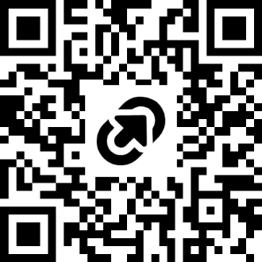

NAME
ADDRESS
CITY, STATE, ZIP
REGISTRATION FEE $20.00 PER PERSON (NUMBER x $20.00) $
BOARD DINNER $20.00 PER PERSON: (NUMBER x $20.00) $
STUDENT, YOUNG ADULT (35 and under) LUNCH SATURDAY Yes
BANQUET: $35.00 PER PERSON (NUMBER x $35.00) $
SPECIAL DIET Please specify:
TOTAL OF ABOVE $
Our meal counts must be in by April 9, 2026
Do you receive the Braille Monitor Yes No
Do you receive the Gem State Milestones Yes No
Please indicate any accommodation’s needed to participate in the Convention.

