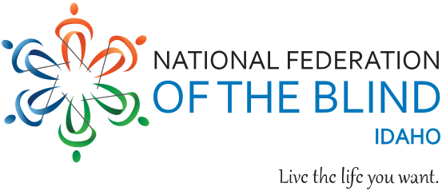

# **National Federation of the Blind of Idaho**

# **Scholarship Program 2025 Application Form**

**Submission deadline: 11:59 PM, February 25, 2025**

Please send the application and all other required documents to

the Idaho State NFB email address: Scholarships.NFBID@gmail.com

All documents must be received by 11:59 PM, February 25, 2025.

No exceptions will be made for applications received after that date.

**Please Note** individuals are limited to receiving an NFBI scholarship a maximum of two (2), times.

Date of Submission (MM/DD/YYYY):

First Name:

Middle Name:

Last Name:

Preferred Name:

Date of Birth (MM/DD/YYYY):

**HOME ADDRESS**

Address line 1:

Address line 2:

City: State: Zip Code:

**CONTACT NUMBERS:** One phone number is required; additional numbers are appreciated. Please specify if numbers are mobile, home, or other.

Primary: Type:

Alternate: Type:

**E-mail Address**:

**ELIGIBILITY**: Students must meet the following four criteria to be eligible: type “Yes,” or “No,” for each item to confirm.

1. I am blind/visually impaired, or functionally blind. (Yes/No):
2. Idaho is My primary state of residence (Yes/No):
3. I will be attending an accredited college or university as a full-time student beginning Fall semester 2025 (Yes/No):

4. If chosen for a scholarship, I will attend the National Federation of the Blind of Idaho State Convention, to be held March 27 through 29, 2025, in Burley, Idaho. (Yes/No):

Have you won a national-state NFB scholarship before (Please note: individuals are limited to receiving an NFBI scholarship a maximum of two (2), times)? (Yes / No):

What types of alternative blindness technique skills do you use in everyday life E.G. long white cane, braille, screen magnifier etc., (list all that apply)?

**EDUCATION:** What school do you currently attend? Write NA if not applicable.

Name of current school, college, or university:

City:

State:

Current GPA:

**FALL SEMESTER**: Which college or university will you attend beginning the Fall 2025 Academic year?

School name:

City:

State:

If undecided at present, list those under consideration with name, city, and state

Under consideration are:

1.

2.

3.

Class standing beginning 2025 academic Year (freshman, sophomore, etc.):

Major(s) you are pursuing:

Degree(s) you are pursuing:

Profession or field of employment you wish to enter with your college degree:

Anticipated year of college graduation:

List any other postsecondary institutions you have attended:

Name of former college 1:

City: State:

Years:

Course of study: Degree earned:

Name of former college 2:

City: State:

Years:

Course of study: Degree earned:

Name of former college 3:

City: State:

Years:

Course of study: Degree earned:

Supporting Documents

**Personal Essay:**

Please submit an essay introducing yourself to the scholarship committee. The committee members will be especially interested in your most notable qualities, your attitude about blindness, and examples of your demonstrated leadership ability. Essays are limited to no more than 700 words. What does the committee need to know about you in 700 words or less?

**Letters of Recommendation:**

Two (2), letters of recommendation, sent to [scholarships.NFBID@gmail.com](mailto:scholarships.NFBID@gmail.com) directly from the person making the recommendation. Letters from family members will not be accepted.

Transcripts:

Provide a current transcript from the education institution you are currently attending and transcripts from all other post-secondary institutions attended.

**Proof of Blindness or Vision impairment:**

A completed certification of Blindness or Visual Impairment document signed by a doctor, VR counselor from the ICBVI, or another qualified professional from a recognized agency providing services to blind or visually impaired individuals.

**NFBI State President Interview:**

All applicants must be interviewed by the President of the National Federation of the Blind of Idaho, Dana Ard. Please contact her by phone at (208) 345-3906, or Pres.NFBIdaho@gmail.com, to schedule a time for the interview.

Note: Microsoft Word format is preferred for all documents.

Please email the completed application form and all 2025 scholarship documents to: Scholarships.NFBID@gmail.com

**Certification Statement:**

By printing or typing my name below, I confirm that all of the information provided above and in the accompanying documents is true and correct to the best of my knowledge.

Printed Name:

Date: