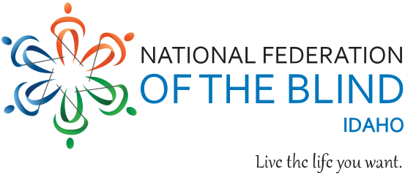

Dear Scholarship Applicant:
The National Federation of the Blind of Idaho (NFBI), awards merit-based scholarships to blind/visually impaired, functionally blind, high school seniors or college students annually. Students who are blind or low vision or receiving services from the Idaho Commission for the Blind and Visually Impaired (ICBVI), attending an accredited college or university the academic school year beginning fall semester 2025 are urged to apply. There will be three (3) merit-based scholarships in the amount of $3,000 awarded at the state convention of the NFBI, March 21 through 23, 2025, in Burley, Idaho. Scholarship finalists will have their expenses paid and are required to attend the convention.
Please Note individuals are limited to receiving an NFBI scholarship a maximum of two (2), times.
The scholarship application can be found at http://www.nfbidaho.org/scholarship
All Application materials must be emailed to scholarships.NFBID@gmail.com no later than February 25, 2025, at 11:59 PM.
The following required Items must accompany each application:
- A completed NFBI Scholarship application form.
- A 700-word essay.
NFBI scholarships are merit based and are awarded based on scholastic achievement, financial need, and service to the community. In preparing your essay, please keep in mind that committee members and decision-makers are all successful blind professionals. Take some time to think how you personally can convey your best qualities in your own words. This is an advocacy job; the committee members will note how you choose to do it.
Please also keep in mind that the awards are restricted to blind/Visually Impaired, and functionally blind persons, so the committee will be interested in what techniques and approaches you personally practice concerning your blindness.
- Two letters of recommendation.
Letters of recommendation must be emailed directly to the committee (scholarships.NFBID@gmail.com) by the person making the recommendation.
Recommendation letters from family members are not accepted.
- Transcripts.
Provide a current transcript from the education institution you are currently attending and transcripts from all other institutions attended.

Please email transcripts to scholarships.NFBID@gmail.com. Transcripts sent via email which require access codes and have an expiration date are not accepted as the Committee works without staff and such transcripts often expire before they have been reviewed and printed.
If you have not yet attended such an institution or have not yet completed one year of study, send a copy of your high school transcript.
- Proof of blindness or vision impairment signed by a doctor, VR counselor from the ICBVI, or another qualified professional from a recognized agency providing services to blind/visually impaired, and functionally blind individuals.
No application will be considered without this certification.

- Interview with NFBI State President.
Applicants must contact NFBI State President, Dana Ard, at
(208) 345-3906, or email pres.NFBIdaho@gmail.com, to schedule an interview.

All application materials must be emailed to scholarships.NFBID@gmail.com and received no later than 11:59 PM, February 25, 2025.

President Ard and the scholarship committee look forward to hearing from you.
The National Federation of the Blind (NFB), is a non-profit organization of blind people who are working to make life better for other blind people. You can receive funding from the Idaho Commission for the Blind and Visually Impaired and still qualify for a scholarship from the NFB, both state and national.
There will be thirty scholarships awarded nationally plus an expense paid trip to the NFB National Convention. President Ard will be happy to submit a letter of recommendation on your behalf after she has had a chance to talk with you. The deadline for the national application is March 31, 2025.
National applications may be completed online at www.nfb.org/scholarships.
We know that blind college students need extra money for specialized equipment and technology, travel, reader service and other necessities. This is an opportunity for blind students to receive funds with no strings attached. The expense paid trip to the national or state convention may be just as important as the scholarship award itself. Past winners have told us that meeting other blind people and finding an advocacy organization which works to improve opportunities for the blind and visually impaired can be just as important as the scholarship itself. We urge you to apply.
Sincerely,
NFBI Scholarship Committee,
National Federation of the Blind of Idaho

The National Federation of the Blind advances the lives of its members and all blind people in the United States. We know that blindness is not the characteristic that defines you or your future. Every day we raise the expectations of blind people, because low expectations create obstacles between blind people and our dreams. Our collective power, determination, and diversity achieve the aspirations of all blind people.

