National Federation of the Blind of Idaho
Dana Ard, President
1320 E. Washington
Boise, ID 83712
(208) 345-3906
pres.nfbidaho@gmail.com

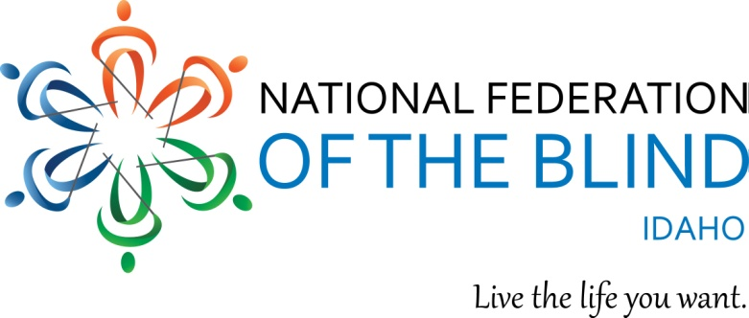
2023 NFBI State Convention Registration
April 27 - 29, 2023 Boise, ID
Riverside Hotel, 2900 W Chinden Blvd. 208-343-1871

“Security, Equality, Opportunity”

Get ready to join our Federation family at the 2023 state convention, April 27-29, at the Riverside hotel, 2900 Chinden Blvd. in Boise.
Room rates are $130.00 per night. Be sure to make your reservations by April 7 at 208 343-1871.
This convention will feature new special events, including aerobic dance and bocci ball provided by the Northwest Association for Blind Athletes and birding by ear directed by our own Al Schneider and other local birders. We will have a vendor expo featuring technology and other interesting exhibits. Speakers will present on topics including progress toward private and independent mail-in voting in Idaho, drug safety and labeling, changes to the Able Act, updates from agencies serving the blind in Idaho, and presentations from our members on travel, guide dog schools, and other inspirational topics. Friday night will feature live music from our own Justin Bonner and his band The Blend, as well as our fundraising auction and gift baskets. We are planning a luncheon for students and young adults, and a meeting for parents of blind children. The Convention will conclude with our banquet, featuring Sheila Wright, as our National Representative, and our 2023 scholarship class.
If you want to have a good time while you learn and grow in our Federation, come join us at the Riverside Hotel on April 27-29. There is something for everyone

We have three ways for you to register for the Convention. If you are paying by check, please send your completed form below and payment to NFB-Idaho Treasurer at treasurer@nfbidaho.org or Don Winiecki 1422 E Woodvine Court, Boise ID 83706-4484. If you would like to pay by credit or debit card, please use the following URL for the online registration and payment page.

https://tinyurl.com/NFB-ID-2023-Convention or you can use the QR code following QR Code to visit the NFB-Idaho E-commerce site to submit your payment. The QR Code is centered immediately below this paragraph.
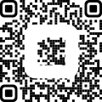

NAME
ADDRESS
CITY, STATE, ZIP
REGISTRATION FEE $20.00 PER PERSON (NUMBER x $20.00) $
BOARD DINNER $15.00 PER PERSON: (NUMBER x $15.00) $
BANQUET: $30.00 PER PERSON (NUMBER x $30.00) $
Salmon: Sirloin:
SPECIAL DIET Please specify:
TOTAL OF ABOVE $
Please indicate any accommodations needed to participate in the Convention.

We will be holding 3 special events at this convention. You must register to attend. Aerobic Dance, Thursday, April 27, 7:00-8:00. The Northwest Association for Blind Athletes will host this event. Come and move your body, and burn some calories to revitalizing upbeat music. No prior experience is required, and all movements can be modified to fit individual needs. NWABA will host Bocci Ball, Friday afternoon from 2:30-3:45. This is a low impact activity that all can enjoy.
Al Schneider will host Birding By Ear, Saturday morning from 7:45-8:45. Come and learn to identify birds by sound.
I wish to register for Dance aerobics YES NO
Bocci ball YES NO
Birding by ear YES NO

There will be childcare available at the convention. If you would like to register your child/children for childcare during the convention, please list your child's/children’s ages below:

We will host a Saturday lunch for our Scholarship winners, other students, and young adults, but only for people younger than 35 years and younger. If you would like to attend this lunch, please indicate YES NO

“We welcome convention sponsorships from our exhibitors and others. $300.00 is a suggested amount but any amount is appreciated.
Our 501 c (3) Tax ID # 23-7039334.

