National Federation of the Blind of Idaho
Dana Ard, President
1320 E. Washington
Boise, ID 83712
Ph.: (208) 345-3906
danalynard@q.com
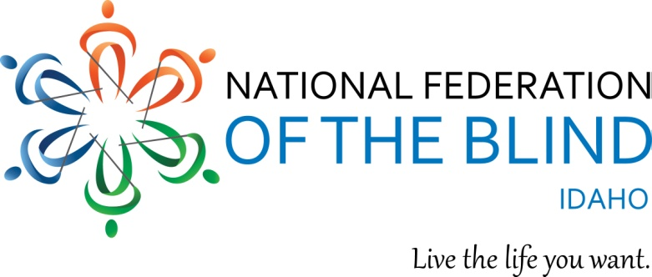

You are invited to the

National Federation of the Blind of Idaho State Convention
April 26-28 at the Red Lion Canyon Springs Hotel
1357 Blue Lakes Blvd. N. Twin Falls, ID 83301

Convention Hotel rates are $81.00 per night for singles, doubles, triples and quads. A $40.00 pending charge will be added to credit and debit cards at the time of check in to cover incidentals. This charge will be removed at check out if there are no incidentals.

The Convention theme is “Raising Expectations and Creating Opportunities.”

Convention registration is $20.00 and will allow you to participate in the Thursday night reception for all attendees and general sessions featuring speakers on topics important to blind and visually impaired people and their families. The Friday blindness product and services expo includes the senior business meeting, student seminar, classes, including an introduction to AIRA, (the visual interpreter for the blind and visually impaired which uses a smart phone app), special glasses with a high resolution camera and a specially trained agent who describes the images seen by the camera, the OrCam for the blind and partially sighted, (an artificial vision device using a light weight smart camera that instantly reads texts, recognizes faces, and reads money notes in real time), parents of blind children discussion group, activities for blind children, viewing and discussion of the documentary “Do You Dream in Color” and much more. See attached registration for costs for the Friday board dinner, and Saturday evening banquet featuring our NFB National representative, Joe Ruffalo, President of the National Federation of the Blind of New Jersey and national board member as our key note speaker.

We guarantee that you will have fun!

- Meeting and talking with other people who are blind and visually impaired who share your interests.

- Learning about new products for people who are blind or visually impaired at the free product and service expo.

- Meeting NFB student leaders and other blind and visually impaired high school and college students.
- Discussing student problems with other blind students and discovering solutions.

- Attending free classes featuring new technologies for the blind and other topics of interest. Enjoying the provocative documentary “Do You Dream in Color”

- Learning from educational and inspirational speakers such as our NFB National representative Joe Ruffalo, blind students who will share their stories, blind parents, with high expectations, competently raising their children, a teacher of blind students who came to the United States from Vietnam, members of our Idaho legislature, representatives from agencies serving the blind and visually impaired and so much more.

Please complete and send the attached registration form including your meal selections and required funds. Meals need to be ordered a week in advance of the event. Enjoy this dynamic event, meet others who are blind and visually impaired, and learn how the National Federation of the Blind of Idaho is raising expectations and creating opportunities. If you have further questions, please contact Dana Ard, President, National Federation of the Blind of Idaho 208-345-3906, or danalynard@q.com.

