National Federation of the Blind of Idaho
Dana Ard, President
1320 E. Washington
Boise, ID 83712
(208) 345-3906
pres.nfbidaho@gmail.com
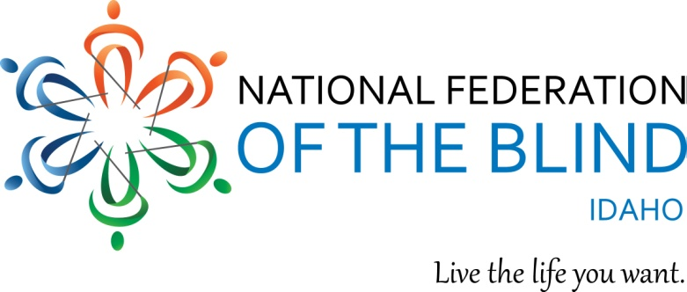

2022 NFBI State Convention Registration
April 21 - 23, 2022 Idaho Falls, ID
Holiday Inn 3005 S. Fork Blvd, Idaho Falls ID 83402, Phone 208-227-9800

“Dream, Believe, Achieve”

You must register for rooms directly with the hotel. Room reservations must be made by April 15, 2022 to get the Convention rate and then complete the rest of the form below.

To make your hotel registration please call the hotel directly at 208-227-9800 and tell them you are part of the National Federation of the Blind group with the room rate of $109.00 plus tax. You may also register with the hotel online at the following URL:
tinyurl.com/NFB-Idaho-2022

NAME
ADDRESS
CITY, STATE, ZIP
REGISTRATION FEE $20.00 PER PERSON (NUMBER x $20.00) $
BOARD DINNER $15.00 PER PERSON: (NUMBER x $15.00) $
SATURDAY BOX LUNCH $ 10.00: (NUMBER x $10.00) $
BANQUET: $30.00 PER PERSON (NUMBER x $30.00) $
Stuffed Tuscan Chicken: Sirloin:
SPECIAL DIET Please specify:
TOTAL OF ABOVE $
Please indicate any accommodations needed to participate in the Convention.

It you are paying by check, please send your completed form and payments to NFB-Idaho Treasurer at treasurer@nfbidaho.org or Don Winiecki 1422 E Woodvine Court, Boise ID 83706-4484

If you would like to pay by credit or debit card, please (a) send your completion of this form to the NFB-Idaho Treasurer at the E-mail or postal address noted above, and (b) use the following QR Code to visit the NFB-Idaho E-commerce site to submit your payment. The QR Code is centered immediately below this paragraph.

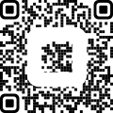

“We welcome convention sponsorships from our exhibitors and others. $300.00 is a suggested amount but any amount is appreciated.
Our 501 c (3) Tax ID # 23-7039334.

Page 2 of 2

