National Federation of the Blind of Idaho
Dana Ard, President
1320 E. Washington
Boise, ID 83712
Ph: (208) 345-3906
danalynard@q.com
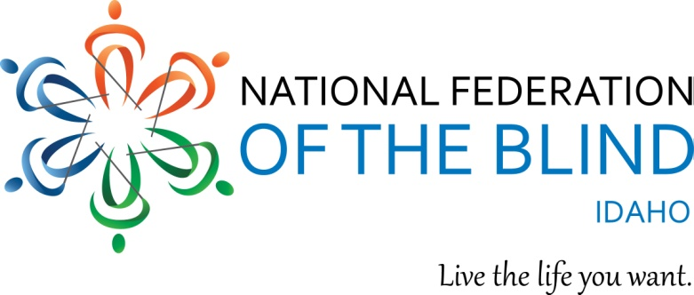

2017 NFBI State Convention Registration
March 23 -25, 2017 Boise, ID
Wyndham Garden Hotel located at 3300 S. Vista Avenue, Idaho
Phone (208) 343-4900
Be sure to state that you are registering for the National Federation of the Blind Convention and you want the room rate of $83.00.

NAME

ADDRESS

CITY, STATE, ZIP

REGISTRATION FEE $15.00 PER PERSON (NUMBER x $15.00) $

BOARD DINNER $15.00 PER PERSON: (NUMBER x $15.00) $
SPECIAL DIET

BANQUET: BEEF MEDALLIONS SALMON SPECIAL DIET
$30.00 PER PERSON (NUMBER x $30.00) $

TOTAL OF ABOVE

Childcare will be available on Friday and Saturday during the General Session and the Banquet. For more information please contact Alison Steven at 208-761-6286 or email at pecans65@gmail.com.

Room rates are $83.00 for singles, doubles, triples, and quads, plus a tax of 13%.
The Hotel Reservation Deadline is March 9. Please send this form and payments to Harry Gawith 410 Avenue H, Boise ID 83712 or email at harygawith@msn.com

“We welcome convention sponsorships from our exhibitors and others. $300.00 is a suggested amount but any amount is appreciated. Our 501 c (3) Tax ID # 23-7039334.

