National Federation of the Blind of Idaho
Dana Ard, President
1320 E. Washington
Boise, ID 83712
(208) 345-3906
danalynard@q.com
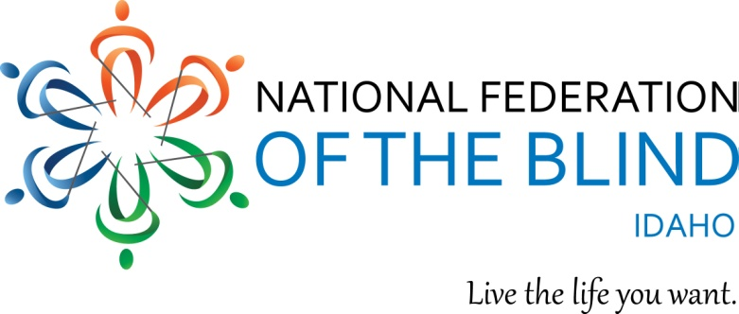

2018 NFBI State Convention Registration
April 26 -28, 2018 Twin Falls, ID
Red Lion Canyon Springs Hotel on Blue Lakes Blvd, Twin Falls ID
Phone (208) 734-5000
“Raising Expectations and Creating Opportunities”
Be sure to state that you are registering for the National Federation of the Blind Convention and you want the room rate of $81.00.
NAME
ADDRESS
CITY, STATE, ZIP
REGISTRATION FEE $20.00 PER PERSON (NUMBER x $20.00) $
BOARD DINNER $15.00 PER PERSON: (NUMBER x $15.00) $
SPECIAL DIET
BANQUET: PRIME RIB SALMON SPECIAL DIET
$30.00 PER PERSON (NUMBER x $30.00) $
TOTAL OF ABOVE $
Childcare will be available on Friday and Saturday during the General Session and the Banquet. For more information please contact Alison Steven at 208-761-6286 or email at pecans65@gmail.com.

Room rates are $81.00 for singles, doubles, triples, and quads, plus a tax of 8%.
The Hotel Reservation Deadline is April 1, 2018. Please send this form and payments to Harry Gawith 410 Avenue H, Boise ID 83712 or email at harygawith@msn.com

“We welcome convention sponsorships from our exhibitors and others. $300.00 is a suggested amount but any amount is appreciated. Our 501 c (3) Tax ID # 23-7039334.

